# Configuration for GoodCom SDK

**1、Using Android Studio as the development tool.**

Take GCNFC.jar and nfc.so as an example, other JAR or nfc.so files can refer to this configuration.

Step1: Put the JAR file in the directory: "Your project\app\libs"

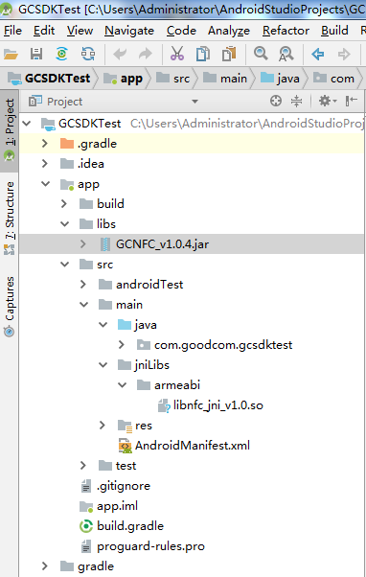

Step2: Create a new jniLibs folder and subdirectory armeabi in the "Your project\app\src\main" directory and place the so file in this directory.

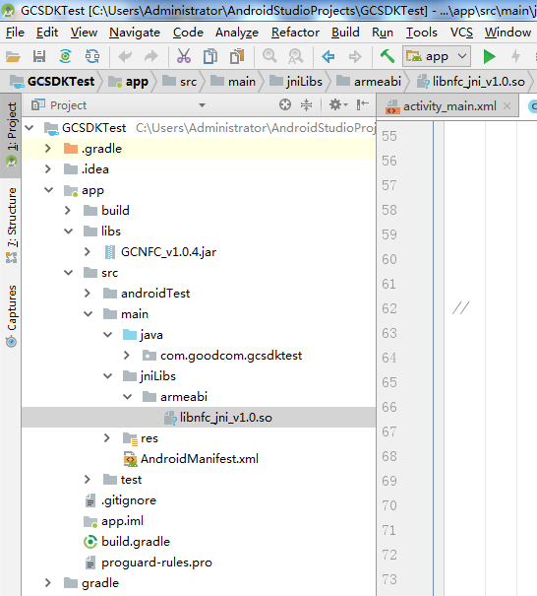

**Finally, you need to synchronize the project.**

With Android Studio old version: Tools->Android->Sync Project with Gradle Files

With Android Studio new version:

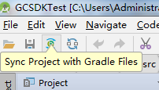

**2、Using Eclipse as the development tool.**

Step1: Put the JAR file in the directory: "Your project\libs"

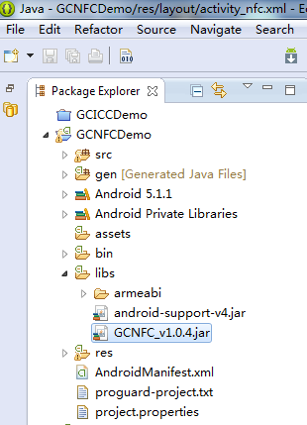

Step2: Create a new armeabi folder in the "Your project\libs" directory and place the so file in this directory.

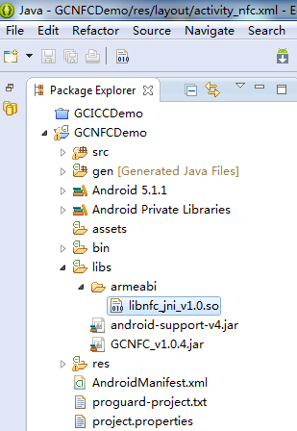

**The above is the JAR and SO file configuration method for NFC SDK, Others like the IC card print can be configured in the same way.**

**3、Using Xamarin as the development tool.**